# Question Review Instructions

Thank you for agreeing to be a subject matter expert reviewer in our research study! This review process takes approximately one hour, including reviewing these instructions.

**Question Purpose**

These questions are provided to students alongside the content of their textbook, as seen in Figure 1. The questions are for students to practice and check their comprehension as they read; they do not produce a score or grade. Students get immediate feedback when they answer and can continue to answer until they get the question correct. Due to their reading comprehension purpose, the questions are intended to be simple, foundational Bloom’s level questions.

Figure 1. A textbook section and accompanying practice questions.

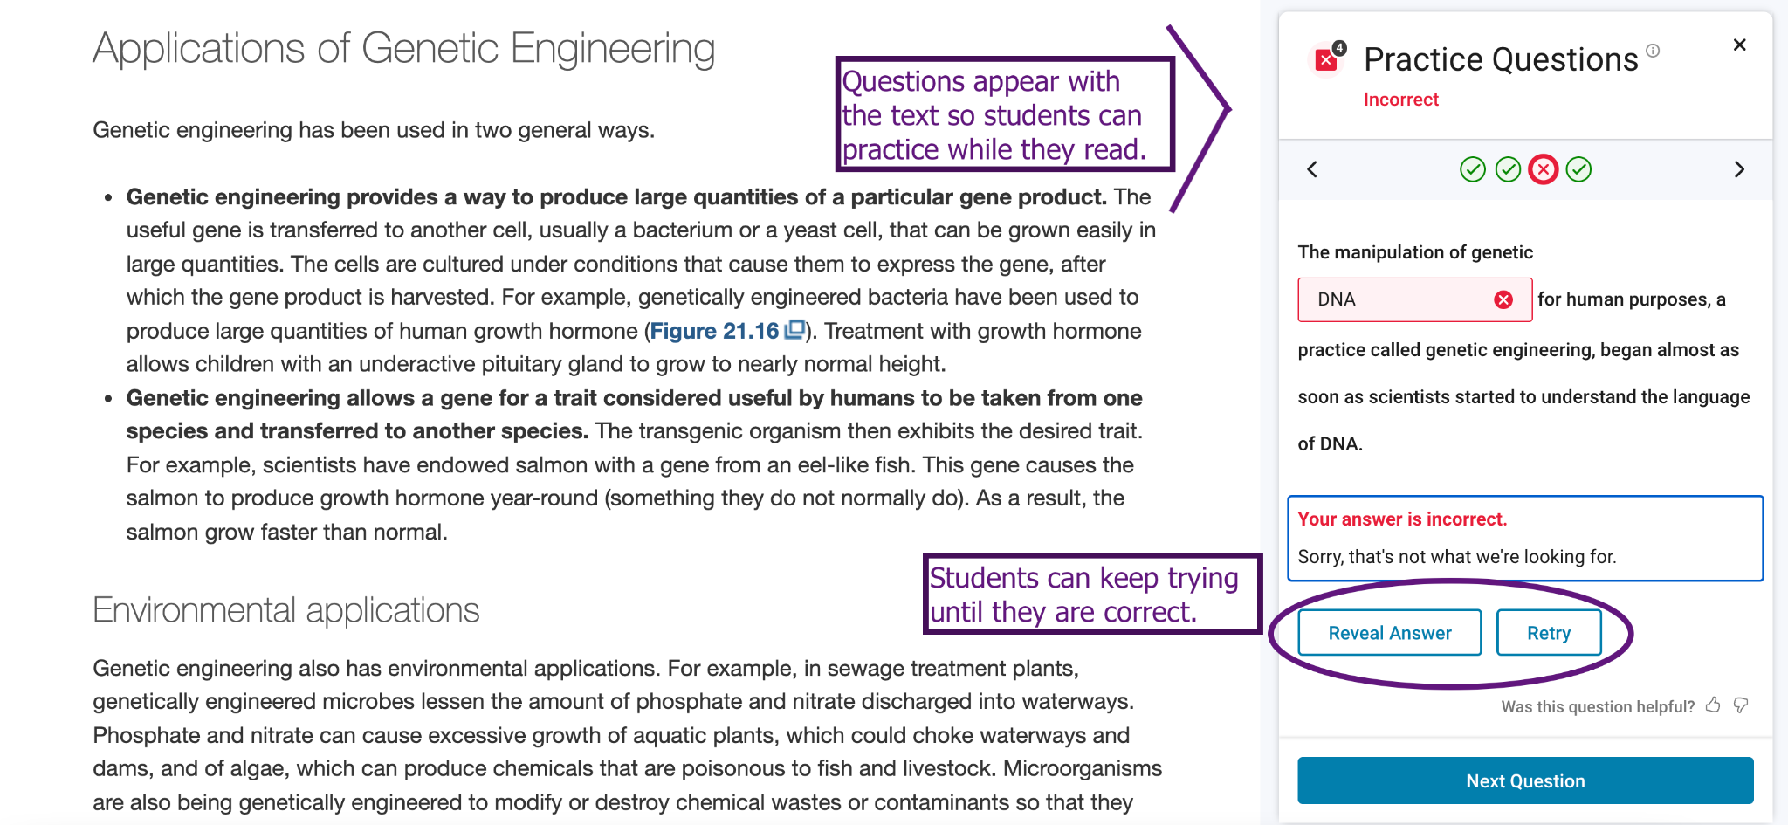

The questions in this review are cloze questions, i.e., sentences with important words omitted as blanks for the student to fill in. There are two kinds of cloze questions:

1. Fill-in-the-blank (FITB) questions, where the student types in a word to complete the sentence (as seen in Figure 1).

Example: No todas las correlaciones tienen sentido y no siempre que se encuentra una correlación puede inferirse ______.

Answer: causalidad

1. Matching questions, where the student matches the words provided to their correct locations in the sentence.

Example: Cuanto más se acerque el ______ a cero, mayor ______ habrá en la ______.

Choices: medición, error, coeficiente

Answer: coeficiente, error, medición

**Rating Procedure**

The spreadsheet provided contains 50 representative questions taken from several chapters of the textbook. You will do your review directly in the spreadsheet (Figure 2), which provides the questions and answers, along with the chapter and section titles from the textbook for context on where they belong. The questions are approximately 80% FITB and 20% matching, which is proportional to what is presented to students.

Figure 2. An example review spreadsheet showing   
the **Rating**/**Reason** and **Question**/**Answer** columns.

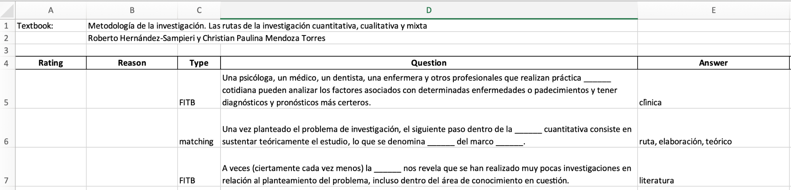

Your task is to rate the questions with respect to whether they would be acceptable reading comprehension questions while a student reads the textbook. There are two columns to fill in for each question: the rating for the question and the reason for that rating (Figure 2). The questions are meant to assess whether a student has read the text and understands the literal meaning of it. Acceptable questions should be grammatical and have a clear answer. However, acceptable questions need not be "deep," challenging, or interesting questions.

For each question, please do the following:

* Read the title of the chapter and section where the question would appear for context about the topic.
* Read the question and think about it in the context of its textbook chapter and section.
* Rate the question on a five-point scale (Table 1) using the dropdown menu in the **Rating** column (Figure 3).
* If the question is not acceptable (rating of 1, 2 or 3), provide the reason for the rating using the dropdown menu in the **Reason** column. The reason code is not necessary if the rating is 4 or 5.

Table 1: Five-point question rating scale.

|  |  |
| --- | --- |
| **Rating** | **Details** |
| 1 Bad | The question has major problems. |
| 2 Unacceptable | The question definitely has a minor problem. |
| 3 Borderline | The question might have a problem, but I’m not sure. |
| 4 Acceptable | The question does not have problems. |
| 5 Good | The question is as good as any I would expect for checking reading comprehension. |

Table 2: Reason codes for why a question was rated 1, 2, or 3.

|  |  |
| --- | --- |
| Ungrammaticality | The question is ungrammatical or does not make sense. |
| Incorrect Information | The question implies something that is obviously incorrect, according to the given context. |
| Vagueness | The question has no simple and clear answer (even a good reader would not know the answer). |
| Awkwardness | The question is very awkwardly phrased (no native speaker of Spanish would say it this way). |
| Other | The question has some other problem that is not one of the above. |

Figure 3. Dropdown menu for rating code.

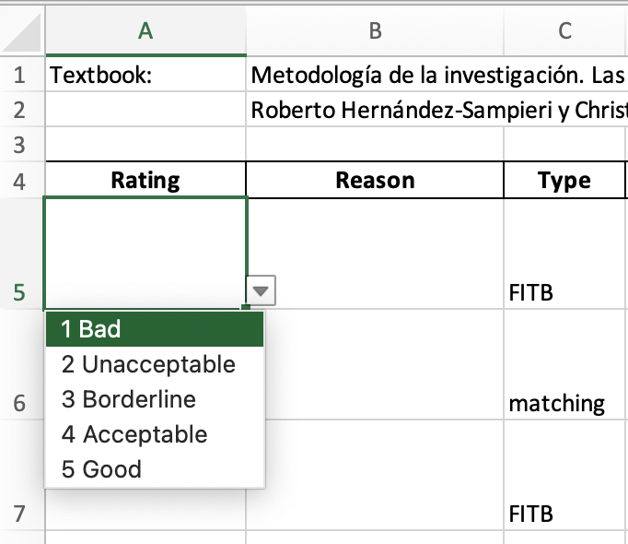

Please email your completed spreadsheet no later than Wednesday, March 23 to Benny Johnson, [benny.johnson@vitalsource.com](mailto:benny.johnson@vitalsource.com). [Please also fill out this form](https://docs.google.com/forms/d/e/1FAIpQLSchN3RepI3XjRnc_rUUyzeXKUQQzfo-uzJvouCvSQ-ywIMY_Q/viewform?usp=sf_link) with your mailing address so we can send your appreciation token. Thank you very much again for your assistance in this research!